Project Activity Report-3

Project Title: “Build a GNU/Linux Distribution”

Team members: Faculty Guide:

Arpan Chavda (09bce006) Dr. Sanjay Garg

Hitesh Piprotar (09bce054) Computer Sci. & Engg. Department



Duration: 8/2/2013 to 28/2/2013

* This time, We are focusing on the development of OpenGujarat.  
  (OpenGujarat is an opensource and free GNU/Linux operating system developed as per the requirement of BISAG.)
* The main objective of this operating system development to develop GUI/Interaction in Gujarati(regional language).

**BISAG’S REQUIRMENT FOR OPENGUJARAT**

* Free and Opensource Linux Operating system in Gujarati
* Can work on Low end computers which has low RAM and graphics
* It must have basic office suits and essential things.
* Improve it via including some Dictionary application from English-Gujarati.

**Basic Build**

* As per our first 2 PARs, We have written about procedure of building basic build containing precompiled linux kernel with essential components.

**System Build**

* This build includes(installed) all essential packages required for operating system and as per bisag’s requirement.
* Applications :
  + - Libre Office(Office suite)
    - GNU Cash (Accountant Application)
    - Basic Audio and Video codecs
    - JRE and Flash Support

**Desktop Environment**

As per requirement, we have included XFCE 4.1 as Desktop Environment for low end computer having low RAM and graphics.

**System Screenshot** 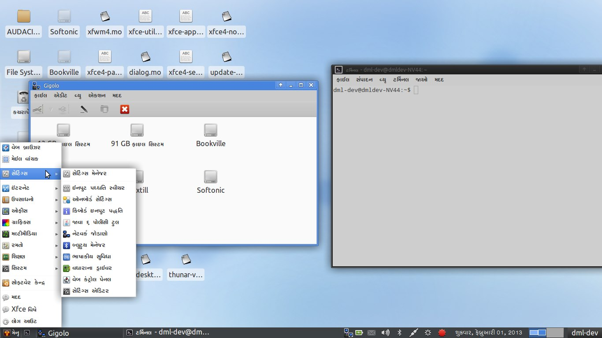

**Analysis of UTF8 Language Translations**

* There are lots of tools available in the market to translate any application to particular language.
* We are stick to the norms of International Language translations regulations so all components can be translated in to Guajarati language.
* We have major problem about source of the templates. There are nothing on the web or any Open source repository to get pre-formatted templates for translation.
* To solve, this problem, we used GNU Gettext utility to convert compiled translated binary files of other language to source file.
* After that we have translated 80% of the components of the operating system.

NOTE: This project is hosted on <http://github.com/codejar-lab/opengujarat> . You can follow our progress and after our project completion other interested persons can also look for study or can improve project.

**Translation and Tools**

* We are using GNU Gettext utility to convert compiled .mo files into .po files.
* .mo files : This files are binary files which are used by Any Application to use translated strings into Application UI.
* .po files : This files are template files in which you can feed your translation strings for Application UI.

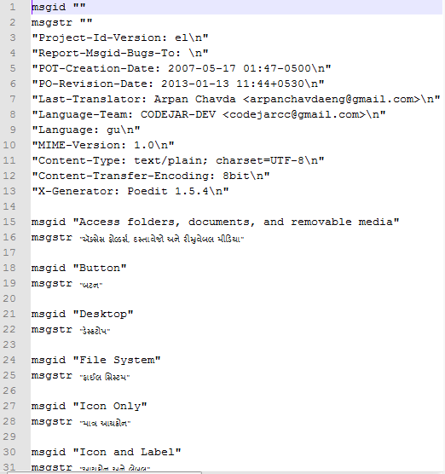

Figure : Sample .po file

**References**

* XFCE Desktop Environment(<http://xfce.org>)
* GNU Gettext utility (<http://www.gnu.org/software/gettext/manual/gettext.html> )
* Gettext Commands(<http://linux.die.net/man/3/gettext>)